Analysis of Battery-Supercapacitor Hybrid Energy Storage System with MPC-based PMSM Control

for Electric Vehicles

Abstract—The devastating impacts of climate change have become increasingly evident in recent decades, with the key responsible sources being the emission of greenhouse gases (GHGs) such as carbon dioxide CO2 and sulfur dioxide SO2. A significant proportion of greenhouse gases (GHGs) originate from the tailpipe emissions of conventional vehicles. Fortunately, electric vehicles (EVs) being a zero carbon transport, have emerged as a potential solution to mitigate the repercussions associated with conventional vehicles. However, there are a few major shortcomings of EVs which include a limited driving range, battery degradation and the technical challenges related to developing a robust and efficient Energy Management System (EMS). To address these issues, this paper presents the design of a rule-based EMS for a semi-active Hybrid Energy Storage System (HESS) consisting Battery and Supercapacitors (SCs) by implementing a smart algorithm that harnesses the regenerating braking for battery charging and optimizes power delivery from the HESS. Additionally, a Model Predictive Control (MPC) method is employed to control the speed of the Permanent Magnet Synchronous Motor (PMSM) of EV. The complete model has been designed and analyzed in MATLAB/Simulink environment under specified conditions and the overall response has been thoroughly studied. The simulation outcomes suggest that the proposed system is capable of enhancing energy efficiency, improving power quality as well as stability, and extending the battery lifespan.

Index Terms—Energy Management System (EMS), Hybrid Energy Storage System (HESS), Supercapacitor (SC), Semi-active Topology, Model Predictive Control (MPC).

1. INTRODUCTION

The most ruinous effect of conventional vehicles on the environment is the emission of various noxious gases such as nitrogen oxides (NOX), carbon monoxide (CO), carbon dioxide (CO2), sulfur dioxide (SO2) and other greenhouse gases (GHGs). A study in 2014 states that, the transportation sector was responsible for 23% of the planet’s total emitted CO2 gas [1]. Between 1990 and 2016, New Zealand’s total increase in GHG emissions from transportation was 71.3% wherein 90.7% of these emissions were from road transport. The increase in transport emissions during that period was 58.8% and 21.3% in Australia and USA respectively [2]. These statistics reveal the dominance of the percentage share of GHG emissions solely from conventional vehicles on the road. For the past few decades, EVs have proved to be a viable option in protecting our environment and combating climate change. As countries worldwide target a low-carbon economy, EVs are playing a critical role in transportation decarbonization. Generally, EVs can be categorized broadly into three types such as: Battery Electric Vehicle (BEV), Hybrid Electric Vehicle (HEV) and Plug-in Hybrid Electric Vehicle (PHEV). The primary energy storage element and the driving force for an EV is the battery. Among numerous types of batteries, Lithium-ion (Li-ion) battery is the most widely used battery owing to its fast-charging ability, compact size, and low maintenance requirements [3]–[5]. While the battery in EVs possesses a high energy density that enables it to supply energy throughout a driving mission, the battery is adversely affected by other significant operations of EVs, including sudden acceleration and deceleration [4]– [6]. Additionally, the frequent charging and discharging of the battery in EVs to meet their power demands contributes to battery aging [7]. Typically, charging an EV to full capacity takes long hours which can be extremely inconvenient for the daily drivers [8]. With the increased number of charge cycles and temperature fluctuations, the performance of Li-ion batteries degrade leading to reduced driving range and battery lifetime [9]. The cost of replacing an EV battery pack can be quite high and battery disposal has a detrimental impact on the environment too [10]. To address these limitations effectively, a promising solution involves integrating batteries and supercapacitors (SCs) in a coupled system. SCs inherently having high power density are the perfect storage element for serving the dynamic power needs of EVs. They can be charged and discharged thousands of times without affecting performance, allowing for enhanced transient performance and extended battery longevity. Moreover, SCs have the capability of receiving high currents from regenerative braking that contributes to increased driving range. Thus, a combination of battery and SC that forms a Hybrid Energy Storage System (HESS) is attracting researchers since HESS blends the benefits of both battery and SC [6]. However, efficiently connecting the SCs and battery to the DC link poses a significant challenge in

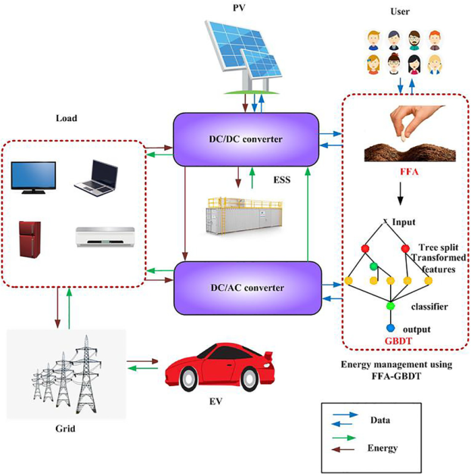

Fig. 1. Schematic diagram of Energy Management System in an Electric Vehicle

the implementation of a HESS. Semi-active HESS topology refers to a configuration where energy storage components, such as batteries and SCs, are interconnected through a DCDC bidirectional converter. A robust EMS centrally controls the power flow among various powertrain components such as batteries, SCs, DC-DC converters, inverters, motors, and more [11]. In this paper, a battery and SC-based semi-active HESS has been designed and simulated for EV. The proposed HESS comprises a Li-ion battery and a SC bank consisting of 100 series-connected SCs, each connected to a DC link bus. For managing the power flow optimally, a rule-based EMS has been designed that ensures synergy between the battery and SCs. An intelligent algorithm has been incorporated into the proposed rule-based EMS that can produce power by harnessing regenerative braking. Finally, an MPC-based motor controller has been established for controlling the speed of the 10 kW, 3-phase PMSM of the EV. The complete model has been designed and simulated in MATLAB/Simulink environment and a performance analysis has been conducted in this study.

1. METHODOLOGY

In this section, the proposed Hybrid Energy Storage System (HESS), Energy Management System (EMS) and Model Predictive Control (MPC) based PMSM control techniques will be discussed in detail. The schematic diagram of the system is depicted in Fig. 1. A. Proposed Semi-active Hybrid Energy Storage System The proposed HESS has been developed based on semiactive topology, which comprises a 265 V, 100 Ah Li-ion battery connected to a bidirectional dc-dc converter, and a 300 V, 10 F SC-bank of 100 SCs directly connected to the DC link bus. The operation of the dc-dc converter is governed to meet the smooth high power demand component. This control is achieved by supplying control pulses to the converter, which are generated based on the filtered reference power demand obtained through the application of an adaptive filtering algorithm [12]. The inverter converts the DC power from the power-sharing bus to AC power, which drives the Permanent Magnet Synchronous Motor (PMSM). Model Predictive Control (MPC), a sophisticated control technique known for its predictive capabilities, is implemented to regulate the operation of the PMSM with precise control. The parameter values and descriptions of the components in the model are provided in Table I. B. Rule-based Energy Management System Algorithm The energy management system (EMS) proposed in this study aims to address the power demand by utilizing both Li-ion battery and SC technologies. Specifically, the rulebased strategy focuses on utilizing the battery to fulfill the high-power and consistent portion of the demand, while the fluctuating part of the demand is handled by the SCs, as shown in Fig 2. TABLE I SPECIFICATIONS OF PROPOSED ELECTRIC VEHICLE MODEL Component Description Value Lithium-ion Battery Nominal Voltage 265 V Capacity 100 Ah Initial State of Charge 50 % Supercapacitor Bank Nominal Voltage 300 V Capacitance 10 F No. of series connected 100 Rated Current 30 A PMSM Rated Power 10 kW Rated Speed 2300 rpm Rated Torque 41.4 N.m DC-Link Voltage 300 V